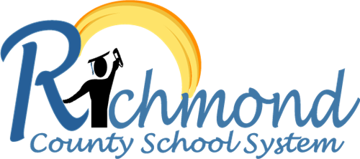

**Mission:**

**The mission of the Richmond County School System is building a world-class school system through education, collaboration and innovation.**